# Web 3 Practical – JavaScript

1. Read the data in the provided data.json file and write to the browser window all the names contained in it.

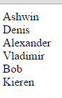

1. Create an array of objects in Javascript, serialize it into JSON and print the serialized object to the browser window.
2. You can't set cookies if your page is not served by a web server. To do this exercise you either need to fire up a local Web server or use an online development service such as <http://liveweave.com/>. If you want to use a local Web server, open the command line window in your lab computer and navigate to the folder where you want to start your web server (the folder where you have your exercise files). Type: >c:\Python27\python.exe -m SimpleHTTPServer 8000 to start a local Web server in your current directory.

Next, create a cookie set to expire 7 days from the current date and verify that it has been correctly stored by the browser.

1. Write the necessary JavaScript code to read the cookie you set up in exercise 3.
2. Create an object in JavaScript and store it in session storage. Check that your data has been stored correctly by using Google developer tools (search in the resources tab).
3. Retrieve the object stored in exercise 5 and output its content to the browser window.
4. Think about how to write a script that checks if a user has visited a page before. Use HTML5 what the storage rather than cookies since it is the most modern way to work. Implement your solution and verify that it works. Upon 1st visit to the webpage, your user should see the following page:

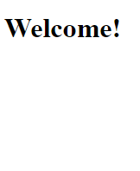

upon the 2nd and subsequent visits they should see:

